East Midlands Coaching and Mentoring Network

Working Collaboratively to Support the Development of Coaching and Mentoring Cultures - a guide to the benefits and operation of the East Midlands Coaching and Mentoring Network



Guide to the East Midlands Coaching and Mentoring Network
The East Midlands Coaching and Mentoring Network has been operating since 2013 and is growing in both organisations in membership and coaches. This guide explores.
- How the network operates and the underlying principles (page 4)
- How members use the network (page 3)
- How the network supports more broadly the development of an organisational coaching culture (page 5)
- The online platform that supports the matching, recording, reporting and evaluation of the coaching/mentoring activity in the network (page 6)
- The costs and requirements of membership of the East Midlands Coaching and Mentoring Network (page 8)
- How membership of the network supports both the coach and coachee (page 7)
What is the East Midlands Coaching and Mentoring Network?
The East Midlands Coaching and Mentoring Network has been designed and is delivered by East Midlands Councils (EMC), the membership body for local authorities in the East Midlands and a not-for-profit public sector organisation. Our goal is to provide continuous support to local authorities in the East Midlands.
The network is.
- A regional network of organisations that share coaches and mentors on a reciprocal basis.
- A regional network of coaches and mentors wanting to make a difference through coaching/mentoring to individuals and organisations in the East Midlands
- A network that is focused on supporting both coachees and mentees, by offering a wide choice of coaches and mentors,
- A network that is focused on supporting coaches/mentors through our continuous professional development workshops and annual conference.
- The network is supported by EMC and facilitated by an online matching and management system; Mye-coach.
The East Midlands Coaching and Mentoring Network was relaunched in September 2019, to include both Coaching and Mentoring, enabling member organisations to share reciprocal coaches and mentors.
Member organisations will now be able to add either coaches or mentors or both to the network and to be able to access both in return.

Why organisations choose to join the East Midlands Coaching and Mentoring Network

Principles that underpin the network
- Quality, cost effective coaching for all.
- Building coaching capacity and sustainability across the region, by developing coaches and coaching capacity within organisations
- Access to a diverse coaching pool of qualified coaches within the region
- Supporting coaches with their development and ensuring quality assurance
- A community of organisations committed to sharing coaches on a reciprocal basis.
- Access to qualified coaches from network organisations for free (Minimum ILM 5 level qualified)
- Choice, based on a coachee driven process, coachees can view and select the most appropriate coach to support their needs.
- Building on the principle of choice the network has a small number of ‘Independent coaches’. These coaches are an additional cost, but this cost is significantly discounted at £165.00 per hour (plus VAT).

How does the East Midlands Coaching and Mentoring Network work?
- Participating organisations identify an organisational coaching lead, who advocate for the Network and Coaching/Mentoring within their organisation. The organisational coaching lead would then join the East Midlands Coaching Network Steering group.
- Organisations commit to provide a specific number of trained coaches or mentors to the network (2 or 4 coaches or mentors depending on the size of the organisation, more details page 8)
- Each coach/mentor will commit to provide 12 hours of coaching per year.
- Organisations will then be able to access the reciprocal amount of coaching/mentoring from the network.
- Coaches/mentors and their coachees/mentees will be linked via an online matching and management platform (Mye-Coach)
- Coaches will have access to coaching skills development sessions, to support their continuing professional development as a coach. Coaches will need to commit regularly to attending a development session to maintain confidence and a quality approach.
- Mentors will be supported through initial development and offered two sessions of development a year as part of their membership subscription.
- Coaches/mentors will have access to a wide range of resources through the Mye-Coach platform
- Coaching and mentoring will be evaluated to ensure the maintenance of ethical and professional standards.

Mye-Coach - online platform to facilitate the East Midlands Coaching and Mentoring Network
The East Midlands Coaching and Mentoring Network is supported by the Mye-Coach online platform which facilitates the selection and matching of coachees to coaches (and mentee to mentor) and enables organisations to view and manage end to end coaching/mentoring activity and requests across their authority. There will be updates to the functionality available on the platform during 2026.
Besides fulfilling their coaching/mentoring commitments within the regional coaching/mentoring network, some authorities also use the Mye-Coach platform to manage their own internal coaching/mentoring pool, further information on how this is undertaken is on page 6.
Benefits of the mye-coach matching platform
For the organisation
- Management and oversight of coaching and mentoring activity - Enables organisations to view and manage their organisations coaching and mentoring activity, having oversight of coaching and mentoring programmes and the number of coaching/mentoring hours taking place.
- Reporting, the Mye-Coach platform includes a reporting function, enabling organisation to report on and analyse data held. Such as number of coaching/mentoring hours, subjects covered by, length of sessions.
- Evaluation built in for both the coach/mentor and coachee/mentee. Organisations can tailor their evaluation questionnaire to suite their internal requirements.
- Security and data protection are recognised as two priorities for the site.

For the Coach/Mentor

- Access to Resources - both coaches/mentors and coachees/mentees can access the resources, and these can be integrated into the relationship.
- Secure recording of coaching/mentoring hours
- Secure messaging system, to enable the communication between coach/mentor and coachee/mentee that is secure and can only be accessed by coach/mentor and client.
- Calendar feed from Mye-Coach to Outlook calendars
- Automated reminders that are emailed to you ahead of your session.
- Supports the development of best practice in the management of coaching/mentoring relationships.

Organisation Support for Coaching/Mentoring Culture Development
Joint organisational working and sharing by those responsible for Coaching/Mentoring within organisations.
A central element of the support provided to organisations in membership of the East Midlands Coaching and Mentoring Network is the East Midlands Coaching Network Steering group. Representatives from each member organisation of the East Midlands Coaching and Mentoring Network meet quarterly. These meetings (held both virtually and face to face) provide an opportunity for steering group members to share organisational activity, as well as a forum to seek advice and support from a shared interest community in coaching and mentoring. The meetings also provide organisations with the opportunity to give continuous feedback to East Midlands Councils as well as helping to develop the CPD programmes.
Building capacity, knowledge, skills, and expertise
Supporting the continual professional development of coaches is a central principle of the network and membership of the network enables coaches to access free development on a quarterly basis. Three half day workshops and an annual coaching conference are offered to each coach.
The CPD sessions are an ideal way for coaches to gain new skills, develop new tool and techniques and learn more about how they, as coaches, can support their clients/coachees.
Previous CPD sessions have included.
- Understanding derailment: How coaches can help coachees get back on track | - Coaching Tools, exploring tools used within coaching sessions
- Team Coaching | - Coaching and Structural Dynamics
- Self-care and coaching | - Coaching for Resilience
- Coaching Virtually (telephone and online) | - Creative Coaching
- Coaching for Neurodiversity | - Coaching for Change

All coaches in the network are required to attend at least two CPD sessions each year to maintain their membership. These sessions should be recorded on their profile on the mye-coach site.
For Mentors
Mentors in the East Midlands Coaching and Mentoring Network will be supported by two annual CPD sessions. One supervision session, an opportunity to reflect on mentoring relationships and access to the annual Coaching and Mentoring Conference.
Ensuring the maintenance of ethical and professional standards
East Midlands Coaching and Mentoring Network Operational Documents
The East Midlands Coaching and Mentoring Network takes an ethical approach to coaching/mentoring and requires those in engaging with the Coaching and Mentoring Network (organisation, coach/mentor, and coachee/mentee) to sign up to our code of conduct and terms and conditions. The network is underpinned by a number of key documents.

- Terms and Conditions – Coach & Mentor
- Terms and Conditions –Coachee & Mentee
- Code of conduct

Coaches in the network are required to sign up to these as part of membership.

Coaching and Mentoring contract - The East Midlands Coaching and Mentoring Network has developed a standard coaching and mentoring contract that we ask coaches and mentors to use as part of the development of their relationship. Coaches in the network are required to complete a contract agreement for all coaching relationships.

Facilitating the Management and Reporting of Internal Coaching/Mentoring Pools
The Mye-Coach platform can be used to facilitate the matching and recording of coaching/mentoring for internal coaching/mentoring pools. An internal coaching/mentoring pool is where coaches/mentors support only internal requests (opposed to requests from the wider Coaching Network member organisations). Some organisations choose to use their membership of the network and access to the Mye-Coach online platform to manage and record coaching activity within their organisation.
What are the benefits of using Mye-coach to facilitate the Management and Reporting of Internal Coaching Pools?
- Enables organisations to view and manage their organisations’ coaching activity.
- Reporting functions, the captured data can then be used as part of analysis or reporting of activity. Such as number of coaching hours, subjects covered by coaching, length of coaching sessions.
- Evaluation built in for both the coach and coachee. The evaluation can be tailored to meet the needs of each organisation, including questions included in the evaluation and the timing when the evaluation is released.

The costs
The annual cost of a single additional ‘internal pool Coach/Mentor’ is £185.00 + VAT for members and associate members of EMC. Additional coaches for non-EMC members are £225.00 + VAT.
If organisations choose to use the Mye-Coach platform to manage all internal coaching/mentoring pool activity, please contact Lisa Butterfill at lisa.butterfill@emcouncils.gov.uk for more information on the costs. Internal pool coaches/mentors will be able to access all CPD sessions and all the resources within the system.
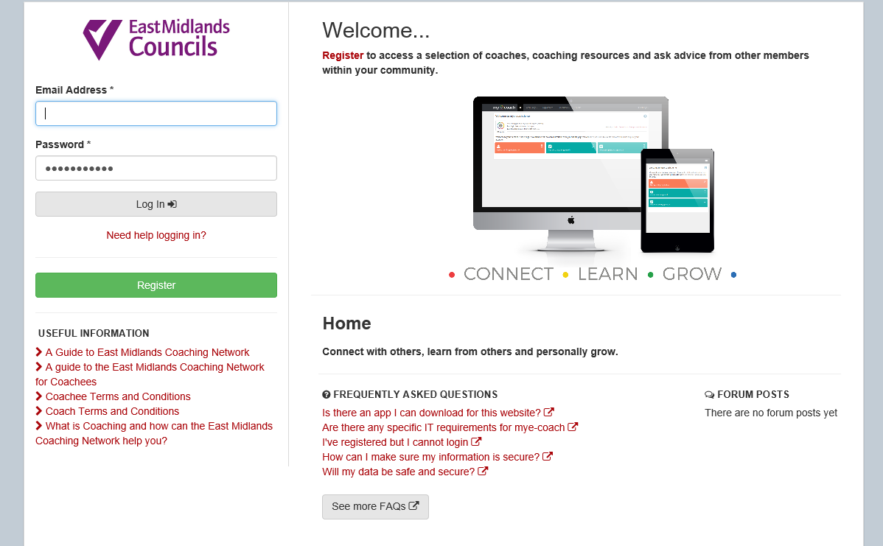
What are the benefits of the East Midlands Coaching and Mentoring Network to participating organisations?
- Quick and easy access to qualified coaches and mentors
- Significant cost savings of at least £20,500 per organisation, far beyond the value of the membership fee
- A means to view and manage coaching and mentoring activity to help develop a sustainable and consistent coaching and mentoring culture within your organisation.
- Develop relationships across the region to aid future collaboration and learning.
- Access to independent coaches at an agreed rate of £165.00 per hour +VAT

What are the benefits to the Organisational Coaching lead?
- The opportunity to build a cross-organisational coaching/mentoring culture and influence the development of the Network.
  - Annual Coaching and Mentoring Conference providing an opportunity to explore the latest coaching/mentoring thinking and techniques
  - The opportunity to work with other organisational coaching leads and share ideas and experiences.
  - Access to the quarterly champion network meetings

What are the benefits to the Coachees/Mentees?
- A choice of qualified coaches/mentors from a range of participating organisations
- Ability to access resources which can help identify your coaching/mentoring needs.
- The opportunity to evaluate your coaching/mentoring outcomes and relationships and have these reflected back to the coach/mentor and your organisation on a confidential basis as appropriate.
- A secure platform for communicating with your coach/mentor outside of the sessions.

What are the benefits to the Coach/Mentor?
- Provide a range of coaching/mentoring opportunities to help build experience and skills.
- Access to a 200 high quality resources; Handouts, Exercises, Diagnostics & Guidelines
- Networking opportunities with colleagues and peer group support
- Access to performance improving events such as skills workshops and supervision and an annual conference to support their continuing professional development.
- Recognition of being part of the East Midlands Coaching Network, with certificates of participation

What are the Benefits of using the mye-coach site to Facilitating the Management and Reporting of Internal Coaching/Mentoring Pools?
- Enables organisations to view and manage their organisations’ coaching/mentoring activity
- Reporting functions, the captured data can then be used as part of analysis or reporting of coaching/mentoring activity. Such as number of hours, subjects covered, length of sessions.
- Evaluation built in for both the coach /mentor and coachee/mentee. The evaluation can be tailored for each organisation.
- Significant cost savings by being part of the network when compared to buying the online platform directly from the provider.

Hear from our Network members.

What does membership of the East Midlands Coaching and Mentoring Network include and what are the costs?
The East Midlands Coaching and Mentoring Network is open to all public, private and voluntary sector organisations in the East Midlands. Membership of the Network includes.
- access to reciprocal coaching/mentoring from member organisations (see table below for details)
- access to the on-line matching, management and development system (Mye-Coach)
- access to the East Midlands Coaching Network Steering group quarterly meting
- access to 4 development sessions for nominated coaches, including the coaching conference.
- access to 2 development sessions for nominated mentors, including the coaching conference.
- advice and support from East Midlands Councils
- access to over 200 different resources available on the Mye-Coach online system
- discounted access to use the Mye-Coach platform to manage coaching activity

Membership type |  | Cost per annum | Commitment to provide coaching/mentoring | Access to coaching
EMC Member Organisations | District/Borough | £595 | minimum 2 trained coaches/mentors (or a mix of both), supplied to the Network. | access 24 hours of coaching or mentoring
EMC Member Organisations | County/Unitary | £1200 | minimum 4 trained coaches/mentors (or a mix of both), supplied to the Network** | access 48 hours of coaching or mentoring
EMC Associate Member Organisations | < 1,000 employees  >1000 employees | £780.00  £1350.00 | minimum 2 trained coaches/mentors (or a mix of both), supplied to the Network.  minimum 4 trained coaches/mentors (or a mix of both), supplied to the Network. | access 24 hours of coaching or mentoring  access 48 hours of coaching or mentoring
Non-Member Organisations | < 1,000 employees | £910.00 | minimum 2 trained coaches/mentors (or a mix of both),** | access 24 hours of coaching or mentoring
Non-Member Organisations | > 1,000 employees | £1780.00 | minimum 4 coaches* supplied to the Network** | access 48 hours of coaching or mentoring

All costs are subject to VAT.

Any additional coaches to the requirements above are charged at £185.00 + VAT per coach for member and associate organisations and £225.00 + VAT for non-member organisations. For this they receive access to the system including resources and the CPD sessions.

Requirements of Coaches
- Coaches must be qualified to ILM Level 5(or equivalent).
- Each nominated coach commits 12 coaching hours per year to the Network.
- Additional coaching sessions may be allocated or can be purchased at low cost. It is recommended that additional coaching sessions are charged at no more than £50.00 per hour.
Requirements of Mentors
- Mentors must be qualified to ILM Level 5(or equivalent) or to have taken part in EMC approved Mentor training.
- Each nominated mentor commits 12 coaching hours per year to the Network
What is the required commitment of my organisation?
At an Organisational level
- contribute at least 2/4 (depending on the organisation) coaches or mentors to the Network.
- support individuals to be coaches/mentors and to be coached or mentored.
- identify and support a Coaching Network Steering Group Member

Coaching Network Steering Group Member
- champion coaching and mentoring and the Network within your organisation.
- provide a single point of contact for coaching and mentoring for the network.
- identify and nominate coaches or mentors (or both) for the Network and inform East Midlands Councils, review annually.
- support and feedback to your coaches/mentors and your coachees and mentees
- receive evaluation reports from the Network organisers.

Coaches/Mentors
- to provide a minimum of 12 hours coaching into the Network
- maintain your skills through CPD including attending the annual coaching and mentoring conference (attending at least two CPD sessions each year)
- maintain your profile on the Mye-Coach site, reviewing annually to ensure it is up to date.
- Complete a coaching contract for each coaching relationship.
- comply with policies on coaching and mentoring set by your organisation and by the Network.
- complete an evaluation of the coaching or mentoring at the end of the process.
- Keep the mye-coach portal up to date with coaching activities, recording coaching hours.

Coachees/mentees
- agree a “contract” with your selected Coach or mentor which will include details on confidentiality.
- complete an evaluation of the coaching/mentoring at the end of the process.
- comply with policies on coaching/mentoring set by your organisation and the Network.
Next Steps
If you are interested in subscribing to the East Midland Coaching and Mentoring Network, please complete the attached Membership Subscription Proforma and return to Lisa Butterfill; if you require further information, please contact lisa.butterfill@emcouncils.gov.uk.
Once an organisation has signed up to become a member and onboarding session(s) will be arranged, which will provide both the coaches/mentors, coaching champions and coachees/mentors with an opportunity to understand how the mye-coach platform works. This will also enable coaches/mentors to complete their on-line coach profiles.
FAQs
What happens if my organisation doesn’t have the required number of qualified coaches/mentors?
The principal goal of the East Midlands Coaching and Mentors Network is to support the development of coaching/mentoring across the East Midlands. With this goal in mind, we are happy to work with organisations that would like to join the network, but on the point of joining do not have the required number of coaches/mentors to contribute the coaching/mentoring hours required to the network. Where this is the case, we work with the organisation to provide support (as required) to enable the organisation to plan for and train additional coaches/mentors within a reasonable timeframe.
This pragmatic approach has been valued by a number of organisations that have joined the network in order to help the development of their coaching/mentoring culture and have trained coaches and mentors concurrently with joining the network. Organisations that have taken this approach have benefitted from access to the Mye-coach site, allowing coaches/mentors in training to use the site to record hours and access the variety of resources and peer support from the other organisations in the network.
How does the matching process work?
The matching process of a coachee/mentee identifying, approaching, and engaging with a coach or mentor is facilitated by the Mye-Coach platform. Using the Mye-Coach platform the coachee/mentee submits a request for coaching or mentoring and identifies a coach/mentor. The process includes organisational checks and balances to ensure that the organisation approves of the initial request. Organisations can choose to request sponsorship approval as part of the process, as the process can be tailored to organisations own processes.
